

Spring 2026

Name: Adil Khan
Roll no: 2610-4011
Department: BS AI

Lab no 1:
<!DOCTYPE html>
<html lang="en">
<head>
<meta charset="UTF-8">
<meta name="viewport" content="width=device-width, initial-scale=1.0">
<title>Adil Khan - Bio Page</title>
</head>

<body>

<h1>Adil Khan</h1>

<p>
Hello! My name is Adil Khan. I am a student interested in
Artificial Intelligence, programming, web development, and
new technologies. I enjoy learning new skills and working
on different academic and programming projects.
</p>

<h2>My Hobbies</h2>
<ul>
<li>Programming</li>
<li>Playing Cricket</li>
<li>Watching Movies</li>
<li>Listening to Music</li>
<li>Exploring New Technologies</li>
</ul>

<h2>Technologies I Know</h2>
<ol>
<li>HTML</li>
<li>Python</li>
<li>C++</li>
<li>SQL</li>
<li>Machine Learning</li>
</ol>

<h2>Favorite Websites</h2>
<p>
<a href="https://www.google.com" target="_blank">Google</a><br>
<a href="https://www.youtube.com" target="_blank">YouTube</a><br>
<a href="https://www.instagram.com" target="_blank">Instagram</a>
</p>

<hr>

<h2>My Picture</h2>
<img src="https://via.placeholder.com/200" alt="Profile Picture" width="200">

<h2>Recent Projects</h2>

<table border="1">
<tr>
<th>Project Name</th>
<th>Description</th>
<th>Technology Used</th>
<th>Completion Semester</th>
</tr>
<tr>
<td>Credit Card Fraud Detection</td>
<td>Detects fraudulent credit card transactions.</td>
<td>Python, Machine Learning</td>
<td>5th Semester</td>
</tr>
<tr>
<td>House Price Prediction</td>
<td>Predicts house prices using regression.</td>
<td>Python, Linear Regression</td>
<td>5th Semester</td>
</tr>
<tr>
<td>Student Management System</td>
<td>Manages student records and information.</td>
<td>C++, OOP</td>
<td>4th Semester</td>
</tr>
<tr>
<td>Online Food Database</td>
<td>Stores and manages food ordering information.</td>
<td>MySQL, SQL</td>
<td>4th Semester</td>
</tr>
</table>

<hr>

<h2>Education</h2>
<ol>
<li>BS Artificial Intelligence - Sir Syed CASE Institute of Information Technology</li>
<li>Intermediate</li>
<li>Matriculation</li>
</ol>

<h2>Skills</h2>
<dl>
<dt><b>Python</b></dt>
<dd>I can write Python programs and develop basic machine learning models.</dd>

<dt><b>C++</b></dt>
<dd>I have knowledge of object-oriented programming and C++.</dd>

<dt><b>HTML</b></dt>
<dd>I can create basic web pages using HTML.</dd>

<dt><b>SQL</b></dt>
<dd>I can create databases and perform SQL queries.</dd>

<dt><b>Machine Learning</b></dt>
<dd>I have studied classification, regression, clustering, and evaluation techniques.</dd>
</dl>

<h2>Contact Me</h2>
<p>
Email:
<a href="mailto:your.email@example.com">your.email@example.com</a>
</p>

<p>
<a href="https://www.linkedin.com/" target="_blank">
Visit My LinkedIn Profile
</a>
</p>

</body>
</html>

Output:
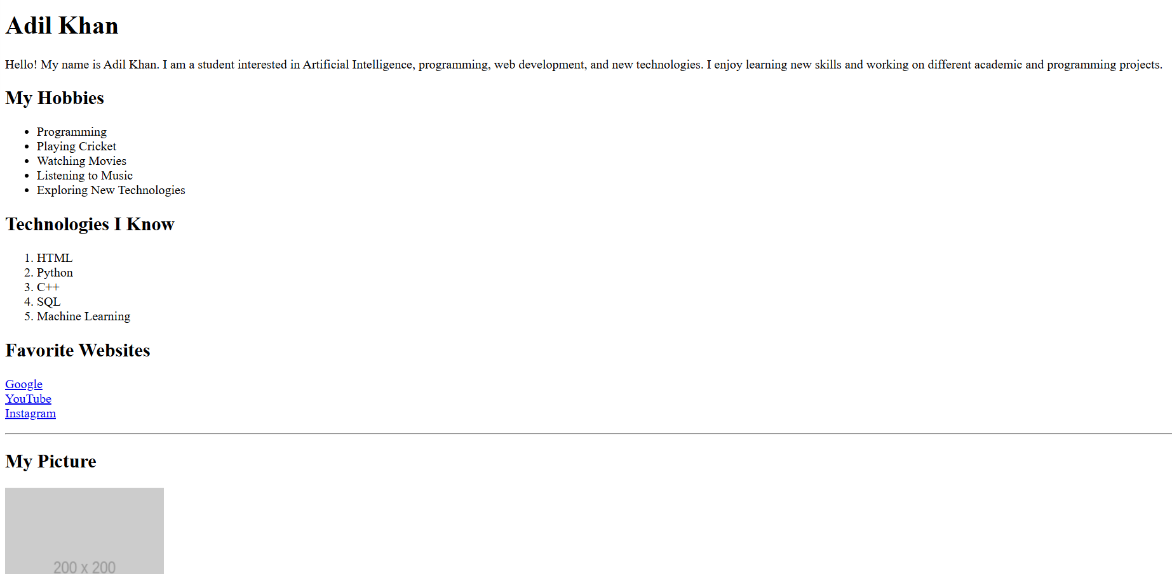

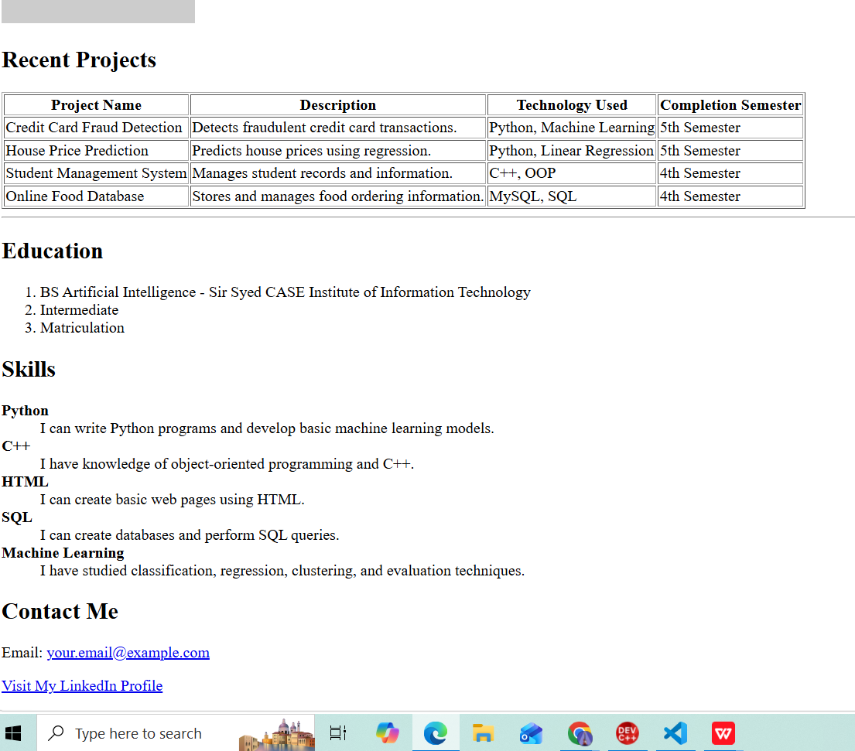

Light house:


